Best Practice Commentary #5 – Frank Muzio

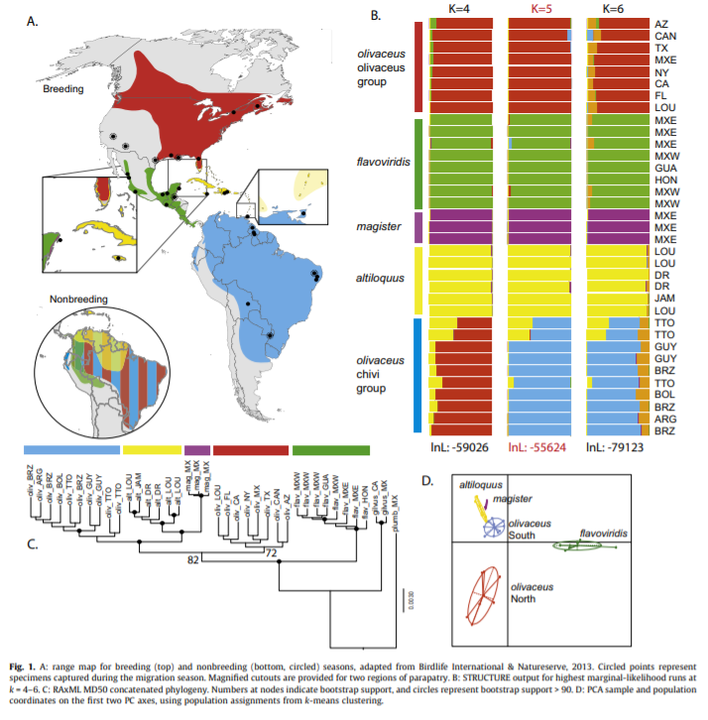

This figure was in a systematics paper that used DNA sequencing to identify two cryptic species within the *Vireo* genus. This figure is broken down into four parts (A-D), and is an overall summary of the species they looked at and their results. While I think this figure does a good job of displaying a lot of important information, there are a few things that I cannot quite follow. Looking at the Fig 1A, they never indicate which color represents which species. One could look at Fig 1B to see the color codes they used for that figure, however there is nothing that explicitly states which color for which species for Fig 1A. Also, the blue for olivaceus does not match any of the blues in the actual figures. I’m not sure if this was just a printing issue or if there is a specific purpose for this, but it is not addressed. Fig 1B has colors that either also don’t match or they were never discussed. For example, I don’t know what the orange in 1B represents and similar to the blue, the green doesn’t seem to match the color used in the legend. Finally, I think 1A is too small for the amount of info it is trying to give. I don’t like the way the call-out boxes are laid out and I think the non-breeding map is too small. Its so small that you can’t see the non-breeding range of *magister*. Overall, I think this figure has the potential to be a great figure, but there seems to be some major oversight in the finer details and overall explanation.

Figure I Like:

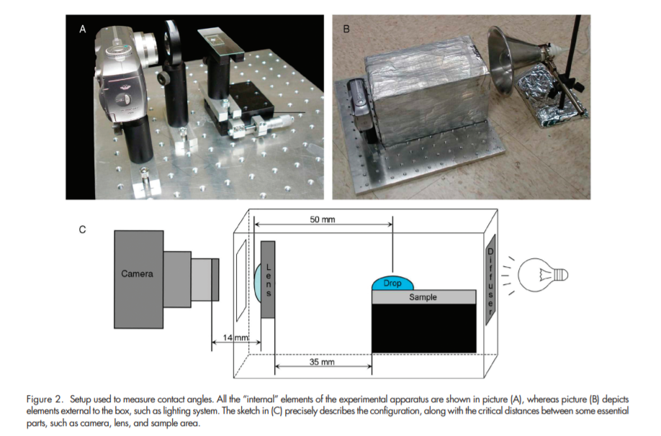This figure comes from a paper that demonstrates methods on how to simply measure the contact angle of a liquid on surface without a lot of fancy equipment. I chose this as a figure that I like because I think it does a great job of demonstrating their set up/methods. I am a big fan of diagrams and pictures that show you exactly what they did in their study. I think often, researchers are not very good at explaining their methods in a way that the reader can fully visualize what they did. The diagram alone does a great job of giving the reader a visual idea, and then adding the pictures gives a real look at the work done. I have read many papers that involve measuring contact angles, and almost all of them have a very vague methods section and makes it difficult to understand what they did, let alone attempt to repeat it. I guess this isn’t really a figure that I could attempt to recreate in R, but sometimes a simple hand or computer drawn diagram and some photos is all that is needed.